

**School of Management (PG)**

**MCA Programme**

**A**

**Assignment**

**On**

*Case study/Project Title*

**Submitted By:**

***Student name***

**Div:A/B/C Roll No.:**

**Batch 2022-24**

**Course Incharge**

**Dr. Dinesh Banswal**

**Academic Year**

**2022-24**

**INDEX**

|  |  |  |
| --- | --- | --- |
|  |  |  |
|  |  |  |

|  |  |  |
| --- | --- | --- |
| Sr. No | Content | Page No. |
| 1 | Introduction, Objective & Scope of the Project |  |
| 2 | Software Requirements |  |
| 3 | Introduction to the Database used |  |
| 4 | ER Diagram |  |
| 5 | Data Dictionary |  |
| 6 | Database Schema |  |
| 7 | DDL Exercises |  |
| 8 | DML Exercises |  |
| 9 | Distinct, Order by Exercises |  |
| 10 | Aggregate functions Exercises |  |
| 11 | Group by Exercises |  |
| 12 | Joins |  |
| 13 | Views |  |

**INTRODUCTION**

**OBJECTIVES**

**SCOPE OF THE SYSTEM**

*Mention the modules of the proposed system*

**SYSTEM REQUIREMENTS**

The environment requirements consist of two requirements for these systems are as follows:

**MINIMUM HARDWARE REQUIREMENT**

PROCESSOR :

HARD DISK :

RAM :

**MINIMUM SOFTWARE REQUIREMENT**

OPERATING SYSTEM :

SYSTEM SOFTWARE :

**INTRODUCTION TO THE DATABASE USED**

The Oracle Database (commonly referred to as Oracle RDBMS or simply as Oracle) is an object-relational database management system produced and marketed by Oracle Corporation.

Larry Ellison and his friends, former co-workers Bob Miner and Ed Oates, started the consultancy Software Development Laboratories (SDL) in 1977. SDL developed the original version of the Oracle software. The name *Oracle* comes from the code-name of a CIA-funded project Ellison had worked on while previously employed by Ampex.

**FEATURES**:

* Active Session History (ASH), the collection of data for immediate monitoring of very recent database activity.
* Automatic Workload Repository (AWR), providing monitoring services to Oracle database installations from Oracle version 10. Prior to the release of Oracle version 10, the Statspack facility provided similar functionality.
* Cluster ware.
* Data Aggregation and Consolidation
* Data Guard for high availability.
* Generic Connectivity for connecting to non-Oracle systems.

Data Pump utilities, which aid in importing and exporting data and metadata between databases.

**ENTITY RELATIONSHIP DIAGRAM**

HAS

NON-EQUITABLE

EQUITABLE

ISA

PORTFOLIO

INVESTMENT BANK

HAS

PORTFOLIO MANAGER

GOES TO

INVESTOR

**DATA DICTIONARY**

MANAGES

BROKER

1. **INVESTOR TABLE:**

|  |  |  |  |  |
| --- | --- | --- | --- | --- |
| Field Name | Data Type | Scale | Description | Constraints |
| INV_ID | NUMBER | 5 | INVESTOR ID | PRIMARY KEY |
| INV_FNAME | VARCHAR2 | 4000 | FIRST NAME | - |
| INV_LNAME | VARCHAR2 | 4000 | LAST NAME | - |
| INV_CITY | VARCHAR2 | 4000 | CITY | - |
| INV_CONT | VARCHAR2 | 10 | CONTACT NO. | - |

1. **BROKER TABLE:**

|  |  |  |  |  |
| --- | --- | --- | --- | --- |
| Field Name | Data Type | Scale | Description | Constraints |
| BROKER_ID | NUMBER | 5 | BROKER’s ID | PRIMARY KEY |
| BROKER_FNAME | VARCHAR2 | 4000 | FIRST NAME | - |
| BROKER_LNAME | VARCHAR2 | 4000 | LAST NAME | - |
| BROKER_CITY | VARCHAR2 | 4000 | CITY | - |
| BROKER_CONT | VARCHAR2 | 10 | CONTACT NO. | - |
| BROKER_COMM | VARCHAR2 | 10 | COMMISSION | - |
| BROKER_STATE | VARCHAR2 | 20 | STATE | - |

1. **PORTFOLIO_MANAGER TABLE:**

|  |  |  |  |  |
| --- | --- | --- | --- | --- |
| Field Name | Data Type | Scale | Description | Constraints |
| PORTMGR_ID | NUMBER | 5 | PORTFOLIO MGR’S ID | PRIMARY KEY |
| PORTMGR_FNAME | VARCHAR2 | 4000 | MGR’S FIRST NAME | - |
| PORTMGR_LNAME | VARCHAR2 | 4000 | MGR’S LAST NAME | - |
| PORTMGR_CONT | VARCHAR2 | 10 | CONTACT NO. | - |
| INV_ID | NUMBER | 5 | INVESTOR ID | FOREIGN KEY |
| PORT_ID | NUMBER | 5 | PORTFOLIO ID | FOREIGN KEY |

1. **PORTFOLIO TABLE:**

|  |  |  |  |  |
| --- | --- | --- | --- | --- |
| Field Name | Data Type | Scale | Description | Constraints |
| PORT_ID | NUMBER | 5 | PORTFOLIO ID | PRIMARY KEY |
| INV_ID | NUMBER | 5 | INVESTOR ID | FOREIGN KEY |
| FINS_ID | NUMBER | 5 | FINAN. INSTRU. ID | FOREIGN KEY |
| PORT_QUANTITY | NUMBER | 5 | QUANTITY | - |
| PORT_PRICE | NUMBER | 5 | UNIT PRICE | - |
| PORT_STATUS | VARCHAR2 | 10 | STATUS | - |

1. **PORTFOLIO EXECUTION TABLE:**

|  |  |  |  |  |
| --- | --- | --- | --- | --- |
| Field Name | Data Type | Scale | Description | Constraints |
| PORT_ID | NUMBER | 5 | PORTFOLIO ID | FOREIGN KEY |
| BROKER_ID | NUMBER | 5 | BROKER’S ID | FOREIGN KEY |
| PORTMGR_ID | NUMBER | 5 | PORTFOLIO MGR ID | FOREIGN KEY |
| PORT_PRICE | NUMBER | 5 | UNIT PRICE | - |
| PORT_STATUS | VARCHAR2 | 10 | STATUS | - |
| BROKER_COMM | VARCHAR2 | 4000 | BROKER COMM. | - |

1. **FINANCIAL INSTRUMENT TABLE:**

|  |  |  |  |  |
| --- | --- | --- | --- | --- |
| Field Name | Data Type | Scale | Description | Constraints |
| FINS_ID | NUMBER | 5 | FINAN. INSTRU ID | PRIMARY KEY |
| FINS_TYPE | VARCHAR2 | 4000 | FINAN. INSTRU TYPE | - |
| FINS_NAME | VARCHAR2 | 4000 | FINAN. INSTRU NAME | - |
| FINS_QUANTITY | VARCHAR2 | 5 | QUANTITY | - |
| FINS_UNITPRICE | NUMBER | 5 | UNIT PRICE | - |

**DATABASE SCHEMA**

1. **BROKER TABLE:**

CREATE TABLE “BROKER"

(

"BROKER_ID" NUMBER NOT NULL ENABLE,

"BROKER_FNAME" VARCHAR2 (4000),

"BROKER_LNAME" VARCHAR2 (4000),

"BROKER_CITY" VARCHAR2 (4000),

"BROKER_CONT" VARCHAR2 (10),

"BROKER_COMM" VARCHAR2 (10),

"BROKER_STATE" VARCHAR2 (20),

CONSTRAINT "BROKER_PK" PRIMARY KEY ("BROKER_ID") ENABLE

)

1. **INVESTOR TABLE:**

CREATE TABLE "INVESTOR"

(

"INV_ID" NUMBER NOT NULL ENABLE,

"INV_FNAME" VARCHAR2 (4000),

"INV_LNAME" VARCHAR2 (4000),

"INV_CITY" VARCHAR2 (4000),

"INV_CONT" VARCHAR2 (4000),

CONSTRAINT "INVESTOR_PK" PRIMARY KEY ("INV_ID") ENABLE

)

1. **PORTFOLIO TABLE:**

CREATE TABLE "PORTFOLIO"

(

"PORT_ID" NUMBER NOT NULL ENABLE,

"INV_ID" NUMBER NOT NULL ENABLE,

"FINS_ID" NUMBER NOT NULL ENABLE,

"PORT_QUANTITY" NUMBER,

"PORT_PRICE" NUMBER,

"PORT_STATUS" VARCHAR2 (10),

CONSTRAINT "PORTFOLIO_PK" PRIMARY KEY ("PORT_ID") ENABLE,

CONSTRAINT "PORTFOLIO_FK" FOREIGN KEY ("INV_ID")

REFERENCES "INVESTOR" ("INV_ID") ON DELETE SET NULL ENABLE,

CONSTRAINT "PORTFOLIO_FK2" FOREIGN KEY ("FINS_ID")

REFERENCES "FINANCIAL_INSTRU" ("FINS_ID") ON DELETE SET NULL ENABLE

)

1. **PORTFOLIO MANAGER TABLE:**

CREATE TABLE "PORTFOLIO_MANAGER"

(

"PORTMGR_ID" NUMBER NOT NULL ENABLE,

"PORTMGR_FNAME" VARCHAR2 (4000),

"PORTMGR_LNAME" VARCHAR2 (4000),

"PORTMGR_CONT" VARCHAR2 (10),

"INV_ID" NUMBER NOT NULL ENABLE,

"PORT_ID" NUMBER NOT NULL ENABLE,

CONSTRAINT "PORTFOLIO_MANAGER_PK" PRIMARY KEY ("PORTMGR_ID") ENABLE,

CONSTRAINT "PORTFOLIO_MANAGER_FK3" FOREIGN KEY ("INV_ID")

REFERENCES "INVESTOR" ("INV_ID") ON DELETE SET NULL ENABLE,

CONSTRAINT "PORTFOLIO_MANAGER_FK4" FOREIGN KEY ("PORT_ID")

REFERENCES "PORTFOLIO" ("PORT_ID") ON DELETE SET NULL ENABLE

)

1. **PORTFOLIO EXECUTION TABLE:**

CREATE TABLE "PORTFOLIO_EXEC"

(

"PORT_ID" NUMBER NOT NULL ENABLE,

"BROKER_ID" NUMBER NOT NULL ENABLE,

"PORTMGR_ID" NUMBER NOT NULL ENABLE,

"PORT_PRICE" NUMBER,

"PORT_STATUS" VARCHAR2 (10),

"BROKER_COMM" VARCHAR2 (4000),

CONSTRAINT "PORT_EXEC_FK" FOREIGN KEY ("PORT_ID")

REFERENCES "PORTFOLIO" ("PORT_ID") ON DELETE SET NULL ENABLE,

CONSTRAINT "PORT_EXEC_FK2" FOREIGN KEY ("BROKER_ID")

REFERENCES "BROKER" ("BROKER_ID") ON DELETE SET NULL ENABLE,

CONSTRAINT "PORT_EXEC_FK3" FOREIGN KEY ("PORTMGR_ID")

REFERENCES "PORTFOLIO_MANAGER" ("PORTMGR_ID") ON DELETE SET NULL ENABLE

)

1. **FINANCIAL INSTRUMENT TABLE:**

CREATE TABLE "FINANCIAL_INSTRU"

(

"FINS_ID" NUMBER NOT NULL ENABLE,

"FINS_TYPE" VARCHAR2 (4000),

"FINS_NAME" VARCHAR2 (4000),

"FINS_QUANTITY" VARCHAR2 (5),

"FINS_UNITPRICE" NUMBER,

CONSTRAINT "FINANCIAL_INSTRU_PK" PRIMARY KEY ("FINS_ID") ENABLE

)

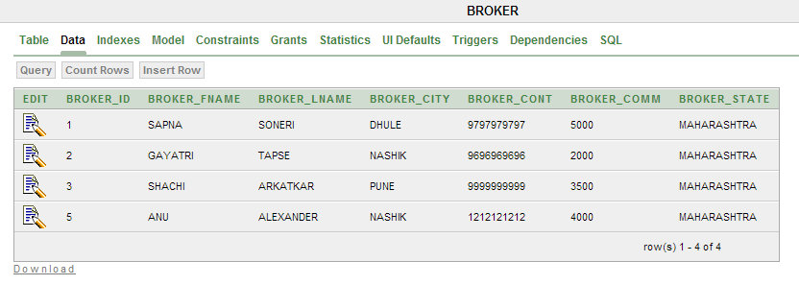

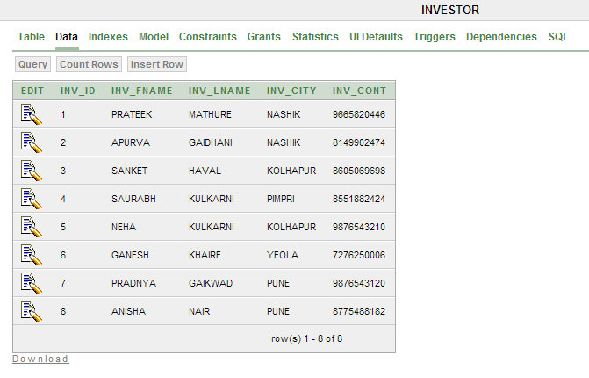

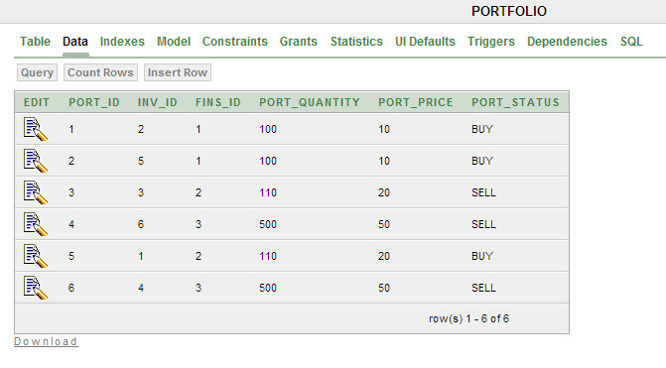

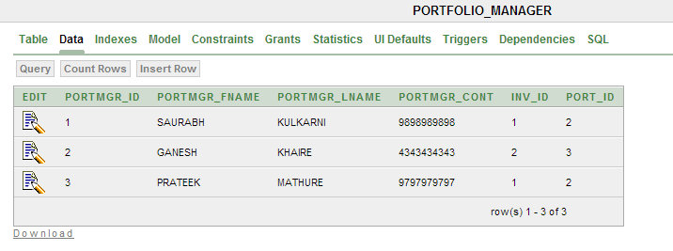

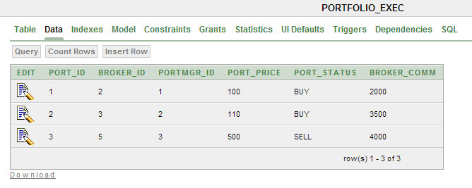

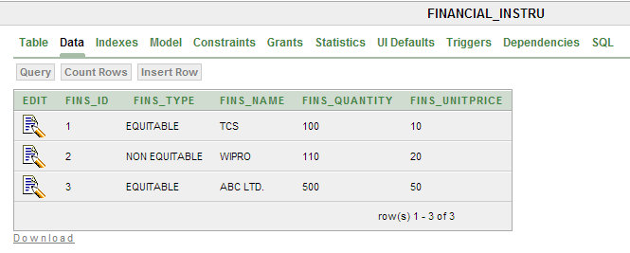

**DDL EXERCISES**

1. **CREATE**:

CREATE TABLE INVESTOR

( "INV_ID" NUMBER NOT NULL ENABLE,

"INV_FNAME" VARCHAR2 (4000),

"INV_LNAME" VARCHAR2 (4000),

"INV_CITY" VARCHAR2 (4000),

"INV_CONT" VARCHAR2 (4000),

CONSTRAINT "INVESTOR_PK" PRIMARY KEY ("INV_ID") ENABLE

);

1. **INSERT**:

INSERT INTO INVESTOR VALUES (8,'PRATEEK','MATHURE','NASHIK','8775488182');

1. **ALTER**:

ALTER TABLE BROKER

ADD BROKER_STATE VARCHAR2 (20);

1. **TRUNACTE**:

TRUNCATE TABLE PORTFOLIO;

1. **DROP**:

DROP TABLE PORTFOLIO_MANAGER;

**DML EXERCISES**

1. **UPDATE**:

UPDATE INVESTOR

SET INV_FNAME='PRATEEK'

WHERE INV_ID=2;

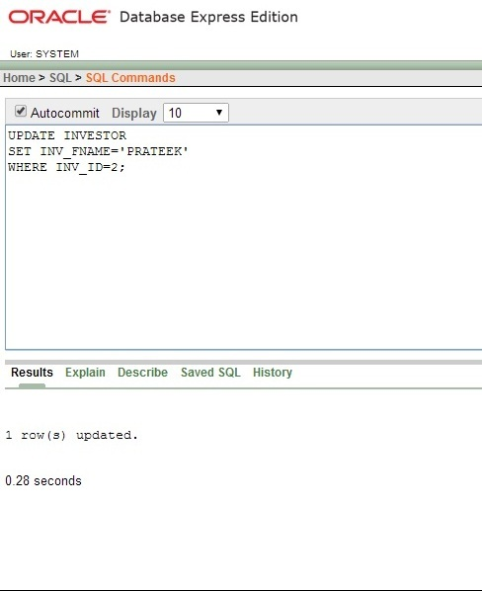

1. **DELETE**:

DELETE FROM BROKER

WHERE BROKER_ID=4;

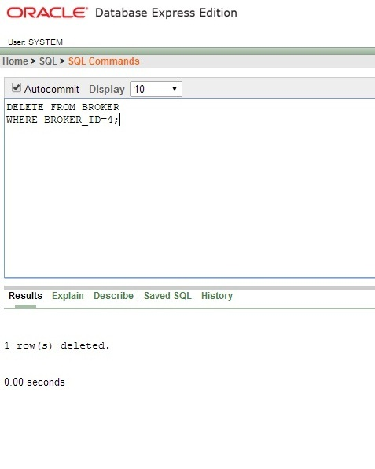

1. **SELECT**:

SELECT *

FROM PORTFOLIO;

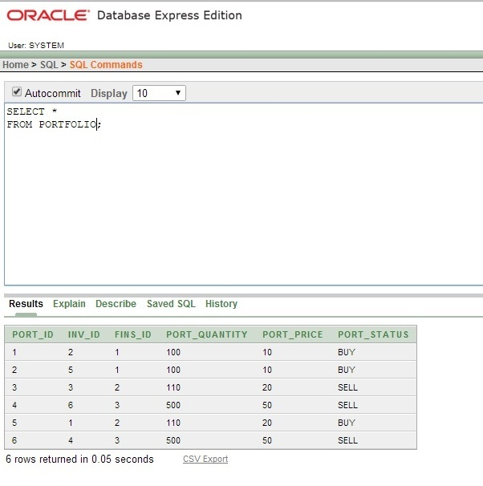

**DISTINCT & ORDER BY EXERCISES**

1. **DISTINCT**:

SELECT DISTINCT FINS_TYPE

FROM FINANCIAL_INSTRU;

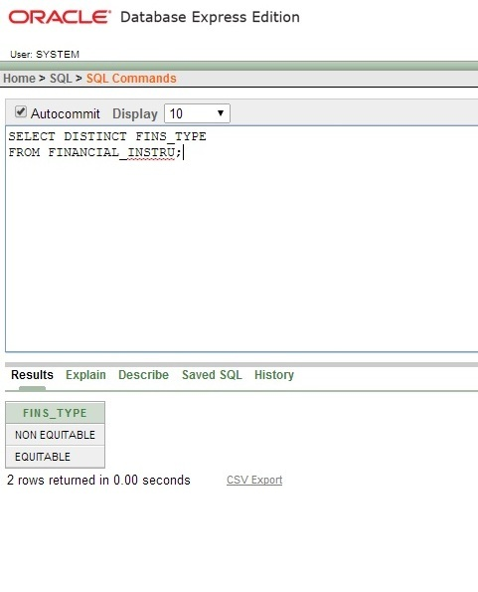2. **ORDER BY**:

SELECT PORT_ID

FROM PORTFOLIO_MANAGER

ORDER BY PORT_ID DESC;

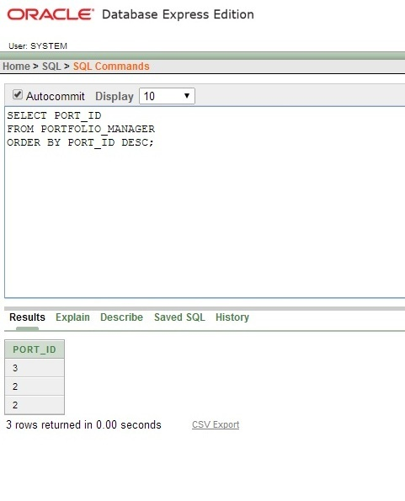

**AGGREGATE FUNCTION EXERCISE**

1. **AGGREGATE FUNCTION**:

SELECT COUNT (*) FROM BROKER;

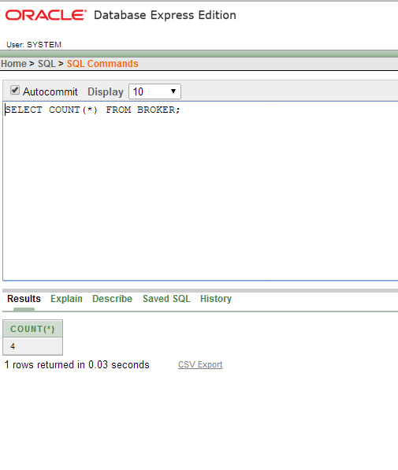

**GROUP BY EXECISES**

SELECT INV_LNAME FROM INVESTOR

WHERE INV_CITY='NASHIK'

GROUP BY INV_LNAME;

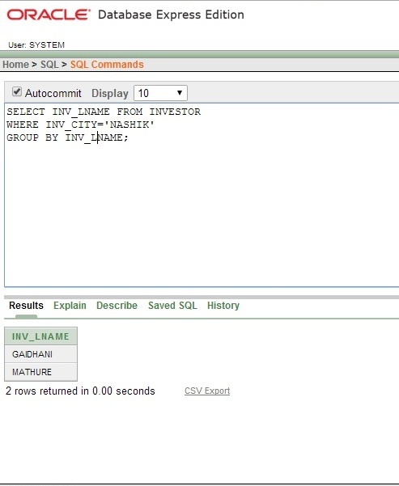

SELECT BROKER_ID FROM BROKER

WHERE BROKER_CITY='DHULE'

GROUP BY BROKER_ID;

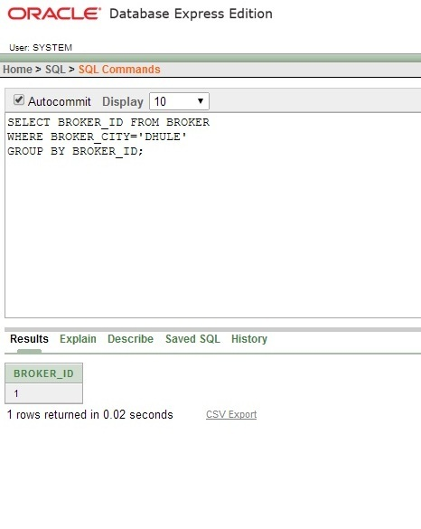

SELECT PORTMGR_FNAME

FROM PORTFOLIO_MANAGER

WHERE PORT_ID=2

GROUP BY PORTMGR_FNAME;

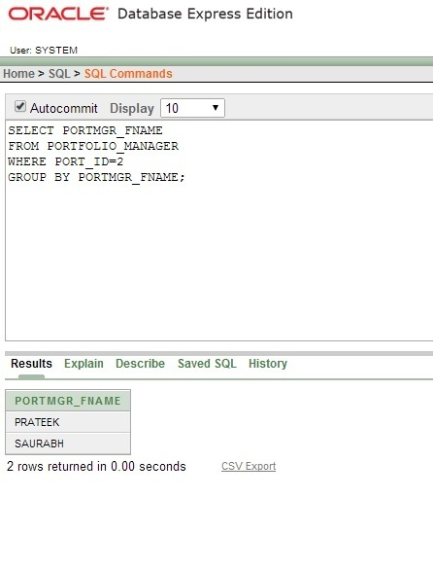

**JOINS**

**INNER JOIN**:

SELECT INV_FNAME, PORTMGR_FNAME

FROM INVESTOR

INNER JOIN PORTFOLIO_MANAGER ON INVESTOR.INV_ID=PORTFOLIO_MANAGER.INV_ID;

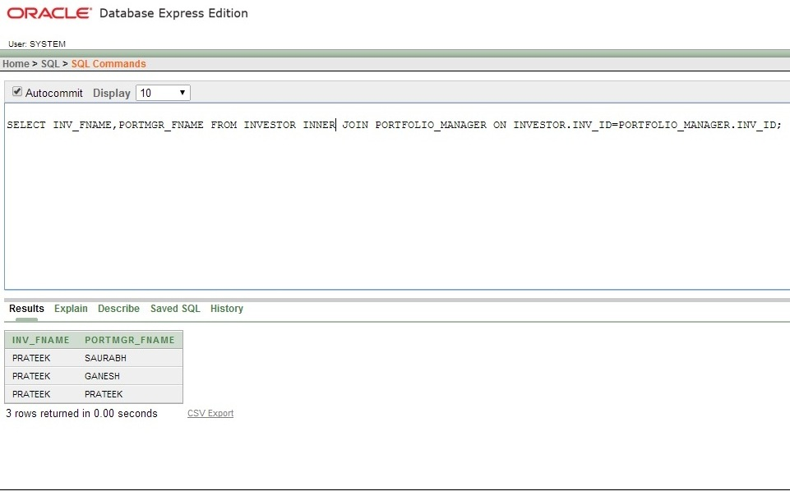**LEFT JOIN**:

SELECT INV_FNAME, PORT_STATUS

FROM PORTFOLIO LEFT JOIN INVESTOR ON PORTFOLIO.INV_ID=INVESTOR.INV_ID;

**RIGHT JOIN**:

SELECT INV_FNAME, PORT_STATUS

FROM PORTFOLIO RIGHT JOIN INVESTOR ON PORTFOLIO.INV_ID=INVESTOR.INV_ID

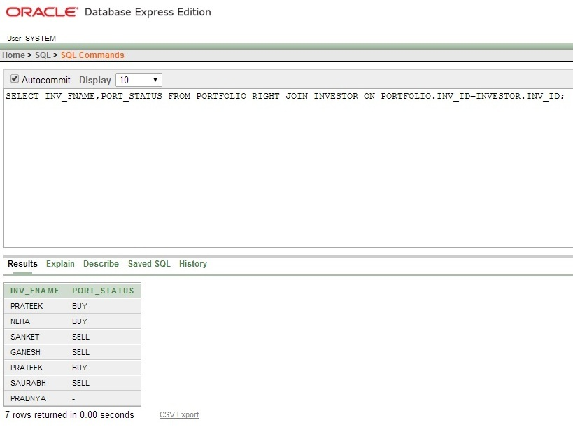

**FULL JOIN**:

SELECT INV_FNAME, PORT_STATUS

FROM PORTFOLIO FULL JOIN INVESTOR ON PORTFOLIO.INV_ID=INVESTOR.INV_ID;

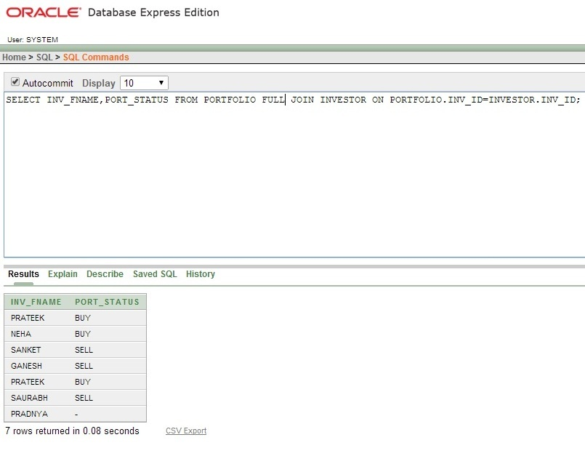

**VIEWS**

1.CREATE OR REPLACE FORCE VIEW "BROK" ("BROKER_FNAME", "BROKER_LNAME") AS

SELECT BROKER_FNAME, BROKER_LNAME FROM BROKER

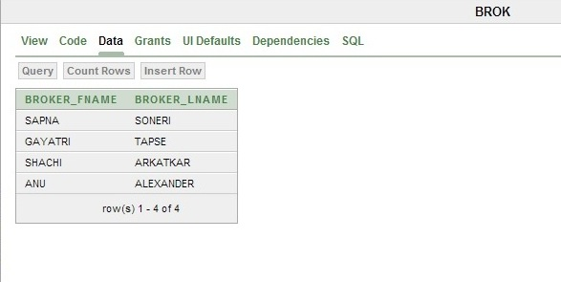

1. CREATE OR REPLACE FORCE VIEW "INV" ("INV_ID", "INV_FNAME", "INV_LNAME", "INV_CITY", "INV_CONT") AS

SELECT "INV_ID","INV_FNAME","INV_LNAME","INV_CITY","INV_CONT" FROM INVESTOR

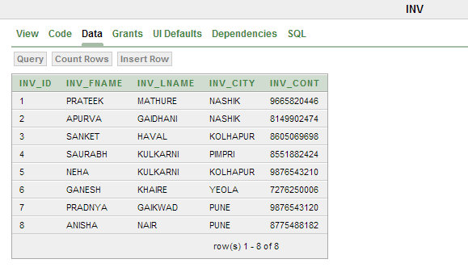

1. CREATE OR REPLACE FORCE VIEW "PORTMGR" ("PORTMGR_ID", "PORTMGR_FNAME", "PORTMGR_CONT") AS

SELECT PORTMGR_ID, PORTMGR_FNAME, PORTMGR_CONT FROM PORTFOLIO_MANAGER

